1… Write the following code:

1. A class named *Arithmetic* with a method named *add* that takes integers as parameters and returns an integer denoting their sum.
2. A class named *Adder* that inherits from a superclass named *Arithmetic*.

**Input Format**

You are not responsible for reading any input from stdin; a locked code stub will test your submission by calling the *add* method on an *Adder* object and passing it integer parameters.

package day7;

public class labQn1 {

    public static void main(String[] args) {

    }

}

class arithmetic{

    int add(int a,int b){

*return* a+b;

    }

}

class adder extends arithmetic{

}

2… In this example, you have a base class Teacher and a sub class ITTeacher. Since class ITTeacher extends the designation and college properties and work () method from base class, we need not to declare these properties and method in sub class.  
Here we have college Name, designation and work () method which are common to all the teachers so we have declared them in the base class, this way the child classes like Math Teacher, Music Teacher and PhysicsTeacher do not need to write this code and can be used directly from base class.

package day7;

public class labQn2 {

    public static void main(String[] args) {

    }

}

class Teacher{

    String designation;

    String college;

    void work(){

        System.out.println("Teacher is Working!");

    }

}

class itTeacher extends Teacher{

    String collegeName;

    String designation;

    void work(){

        System.out.println("IT-Teacher is Working!");

    }

}

class mathTeacher extends itTeacher{

}

class physicsTeacher extends itTeacher{

}

class musicTeacher extends itTeacher{

}

3… Class A serves as a base class for the derived class B, which in turn serves as a base class for the derived class C. (Which type Of Inheritance explain with an example)

package day7;

public class labQn3 {

    public static void main(String[] args) {

        System.out.println("Multi-Level-Inheritance");

    }

}

4…Consider a scenario where Bank is a class that provides functionality to get the rate of interest. However, the rate of interest varies according to banks. For example, SBI, ICICI and AXIS banks could provide 8%, 7%, and 9% rate of interest.

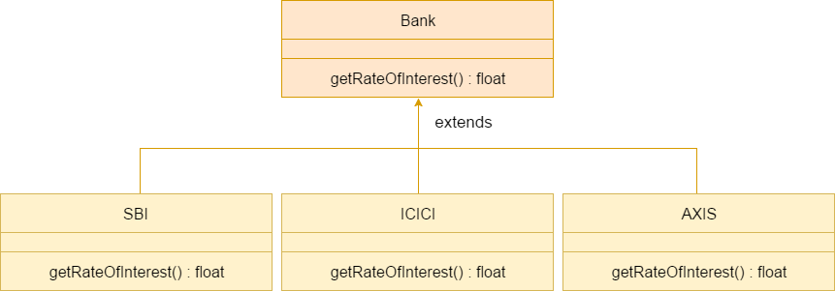

package day7;

public class labQn4 {

    public static void main(String[] args) {

    }

}

class Bank{

    float getRateOfInterest(){

*return* 12.33f;

    }

}

class SBI extends Bank{

    float getRateOfInterest(){

*return* 8.00f;

    }

}

class ICICI extends Bank{

    float getRateOfInterest(){

*return* 7.00f;

    }

}

class axis extends Bank{

    float getRateOfInterest(){

*return* 9.00f;

    }

}